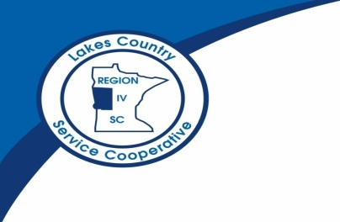
Greetings High School Partners,
We have some news about our online college level offerings for the upcoming 2011-2012 academic year. Minnesota State Community and Technical College (M State) and Lakes Country Service Cooperative have been partners with the Distance Minnesota Consortium Colleges in the OCHS program since 2005.
M State has decided to leave the Distance Minnesota consortium in order to focus more on the needs of our eCampus students, programs, and services. This decision will allow us greater flexibility to respond to the needs of our students and other partners. As a result of this decision, M State and Lakes Country Service Cooperative will also be leaving OCHS starting with the fall 2011 semester.
M State and Lakes Country Service Cooperative remain excited to continue providing online college course options for students remaining in the high school setting through our new eCampus in the High School program. This new option will continue the strong tradition we have in offering course options in partnership with Lakes Country Service Cooperative and Minnesota high schools.
We have listened to your positive feedback and suggestions for improvement over the years, and we have created eCampus in the High School keeping those items in mind. Our goal with eCampus in the High School is to provide schools and students with a streamlined approach, while focusing on high-quality, high-demand online course options.
We are enclosing the eCampus in the High School eligibility requirements and the eCampus in the High School Frequently Asked Questions document. Please do not hesitate to contact me at Jill.Abbott@minnesota.edu or (218) 846-3796 or Inger Wegener at iwegener@lcsc.org or (218) 739-3273 with any questions or suggestions for courses for the fall 2011 and spring 2012 term. We have additional course options we may be able to offer, and we want to know about your needs.
Thank you for your partnership and work with students.
Regards,
Jill Abbott, Dean
M State
Inger Wegener, Career and Technical Education Specialist
Lakes Country Service Cooperative

